**Overview**

Simple Description: Teams will be challenged to create a simple machine where a marble moves through a series of chain reactions to ultimately turn on a light bulb.

**THE CHALLENGE:**

Teams will design, construct and test a simple machine where a marble moves through a series of chain reactions to ultimately turn on a light bulb. In building the machine, teams should make sure that it completes a structured series of tasks within 3 minutes and ultimately turns on the light at end of the process. At the end of the challenge teams will present and explain their device describing the conversions in energy. This type of machine is often called a Rube Goldberg Machine.

**Rube Goldberg**

Rube Goldberg (1883-1970) was an engineer that went on to become a Pulitzer Prize winning cartoonist. His engineering background played a large role on his famous cartoons of “inventions” that were complex devices that performed simple tasks. Rube Goldberg is the inspiration for this challenge. The importance of his inspiration has gone as far to as to become an adjective in Webster’s dictionary that states “accomplishing by complex means what seemingly could be done simply.”

Visit <http://pbskids.org/zoom/activities/sci/rubegoldberginventio.html>

For ideas to share with students.

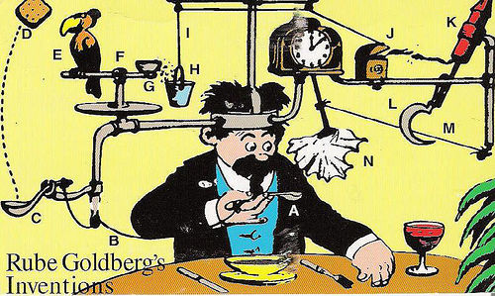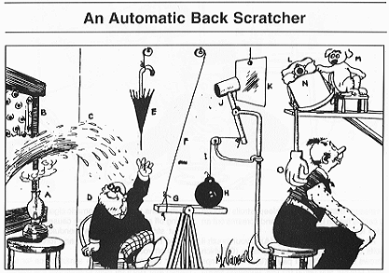

The machines must accomplish the following:

* Transport a marble through the device from start to finish in 3 minutes or less (it does not have to be the same marble, a marble can hit another marble and set it into motion)
* Have 5 energy conversions during the transportation of the marble over at least 3 levels and create a chart illustrating them (Ex: Potential by position to kinetic mechanical as the marble rolls to kinetic mechanical as the marble starts a wheel turning to sound energy as the moving wheels makes a bell ring)
* Ring a bell
* Create a chemical reaction with visible evidence it occurred
* Turn on a light bulb to end the process

Provide each team with a “Tool Box” of the following materials

* marbles of assorted sizes
* ruler
* masking tape
* duct tape
* scissors*
* utility knife*
* modeling clay
* rubber bands
* assorted paper clips
* assorted binder clips
* string
* push pins
* pencils
* wire
* small light bulb
* small light bulb base
* Discovery Dollars

Set up a “store” with the following materials for teams to purchase with their Discovery Dollars. Be sure to have enough of each for multiple teams.

* boxes of various sizes
* plastic bins of various sizes
* plastic/paper cups of various sizes
* wide craft sticks
* balloons
* candles
* matches*
* pipe cleaners
* Slinky
* funnels
* straight pins
* plastic cd cases
* cardboard tubing
* poster board
* pipe insulation tubes
* pool noodles
* straws
* dominos
* mouse traps*
* spatulas
* aluminum foil
* plastic wrap
* thread spools
* compressed air
* springs
* various magnets
* Matchbox cars
* assorted pulleys
* assorted jingle bells
* bicycle bell
* 16oz bottles of water
* 3% hydrogen peroxide
* yeast
* baking soda
* white vinegar

A [Snap Circuit set](http://www.amazon.com/Elenco-SC-100-Snap-Circuits-Jr/dp/B00008BFZH/ref=pd_sim_t_4) can also be the source of many of the things teams will need to meet the challenge

For younger students domino rally sets with ramps and chutes or the game Mousetrap can be good to introduce them to the concept of the marble causing things to happen as it travels along its path.

*Instruct students on the safety precautions when using matches, scissors, utility knifes and mouse traps